Themenblock 16: ART & THE POWER OF IMAGES

CATEGORY A: CONTRASTING IMAGES

TASK SET A1: Authentic vs. Curated — Social Media Identity



PART 1 — Individual Long Turn
Task:
Give a five-minute talk on authentic vs. curated in which you
- Describe, compare and contrast the two pictures above.
- Analyze how social media has changed the way people present themselves visually.
- Comment on your relationship and experience with filters and image editing online.

PART 2 — Paired Activity
Task: Your school is creating a 'Real vs. Filter' awareness campaign for Mental Health Week to help students develop a healthier relationship with social media images. You and your partner are on the campaign design team.
Discuss the following campaign elements and agree on three main messages to include:
- How filters and editing distort our perception of 'normal' appearance
- The mental health impact of comparing yourself to curated images
- Recognizing when influencer content is staged or sponsored
- Strategies for curating your feed to include more authentic content
- The value of 'photo-free' moments and digital detox

TASK SET A2: Commercial Art vs. Public Art

PART 1 — Individual Long Turn


Task:
Give a five-minute talk on commercial art vs. public art in which you
- Describe, compare and contrast the two pictures above.
- Analyze who controls public visual space in modern cities
- Discuss whether cities should regulate advertising to protect public art spaces.

PART 2 — Paired Activity
Task: You have been invited to meet with your city council's Urban Planning Committee to discuss a proposed 'Visual Environment Policy' that would affect advertising and public art in your town.
Before your meeting, discuss these policy proposals and agree on three to recommend:
- Limiting the size and brightness of commercial billboards in residential areas
- Creating designated 'mural zones' where street artists can legally create public art
- Requiring advertisers to fund public art installations as a condition of billboard permits
- Banning digital/video advertising screens in historic town centers
- Establishing a community vote process before any large advertisement is approved

TASK SET A3: Art in the Smartphone Age

PART 1 — Individual Long Turn
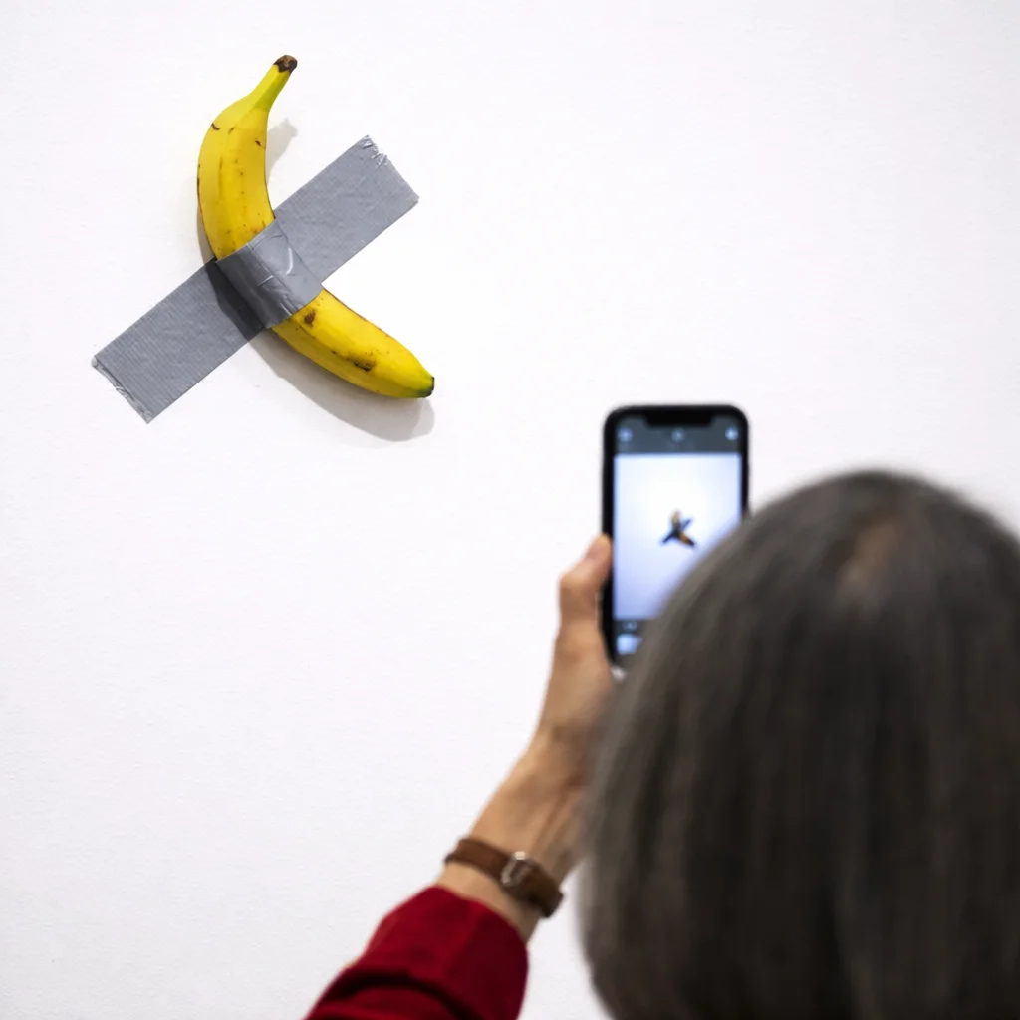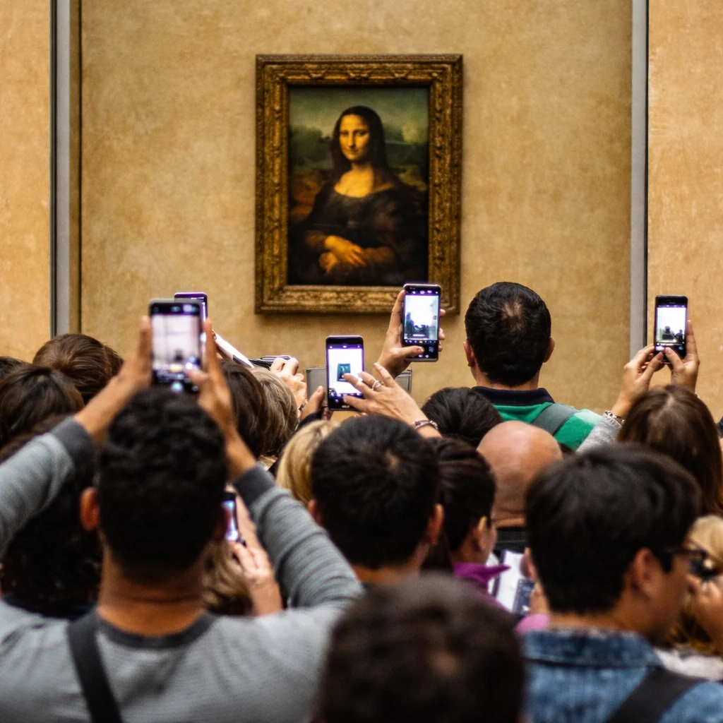

PART 1 — Individual Long Turn
Task:
Give a five-minute talk on experiencing art in the smartphone age in which you
- Describe, compare and contrast the two pictures above.
- Analyze what determines an artwork's cultural value.
- Comment on what it means to truly 'experience' a work of art in today's digital age.

PART 2 — Paired Activity
Task: Your school is organizing an art exhibition exploring the theme 'What Is Art Worth?' The exhibition will feature both classical reproductions and contemporary conceptual pieces, and you need to create an engaging experience for student visitors.
Discuss the following exhibition elements and agree on three priorities:
- Whether to allow or ban smartphone photography during the exhibition
- How to present conceptual art pieces so visitors take them seriously
- Whether to include information about artwork prices and sales records
- How to encourage genuine engagement rather than quick 'selfie and move on' behavior
- What interactive elements could help visitors reflect on the meaning and value of art

CATEGORY B: QUOTES

TASK SET B1: The Power of Advertising Images
Quote 1:
"Publicity proposes to each of us that we transform ourselves, or our lives, by buying something more."
— John Berger, Ways of Seeing (1972)
Quote 2:
"Industrial societies turn their citizens into image-junkies; it is the most irresistible form of mental pollution."
— Susan Sontag, On Photography (1977)

PART 1 — Individual Long Turn
Task:
Give a five-minute talk on the power of advertising images in which you
- Analyze and compare the two quotes above.
- Evaluate whether these 1970s concerns have become more or less relevant in today's social media age.
- comment on your experience with advertising images and their promised 'transformations.'

PART 2 — Paired Activity
Task: Your school is hosting a debate on the motion: 'Advertising does more harm than good to society.' Take opposing positions and discuss the following aspects, then try to reach a balanced conclusion:
- Economic benefits of advertising (jobs, information, competition) vs. psychological harm
- Freedom of commercial speech vs. protection from manipulation
- Advertising's role in funding free content vs. 'mental pollution'
- Personal responsibility vs. corporate regulation
- The specific impact of advertising on young people and body image

TASK SET B2: Photography and Truth
Quote 1:
"Photographs furnish evidence. Something we hear about, but doubt, seems proven when we're shown a photograph of it."
— Susan Sontag, On Photography (1977)
Quote 2:
"Every image embodies a way of seeing. Even a photograph."
— John Berger, Ways of Seeing (1972)

PART 1 — Individual Long Turn
Task:
Give a five-minute talk on photography and truth in which you
- Analyze and compare the two quotes above.
- Discuss how digital manipulation and AI-generated images have complicated our ability to trust photographic evidence.
- comment on a personal experience with a misleading or differently interpreted image.

PART 2 — Paired Activity
Task: Your media studies class is conducting a research project on 'Visual Media and Truth in the Digital Age.' You and your partner are designing the research focus.
Discuss these research questions and agree on three to prioritize for your study:
- How has the ease of image manipulation changed public trust in visual media?
- What techniques do journalists use to verify the authenticity of images?
- How do different generations respond to claims that images have been 'faked'?
- What responsibility do social media platforms have for AI-generated misinformation?
- How can schools teach critical viewing skills for the deepfake era?

CATEGORY C: ALTERNATIVE PROMPTS

TASK SET C1: The Visual Bombardment — Advertising Exposure Statistics

Text Extract
THE VISUAL BOMBARDMENT Research estimates that people in industrialized countries are exposed to between 4,000 and 10,000 advertisements every day through smartphones, social media, websites, television, and public spaces. However, studies show that we consciously notice fewer than 100 of these daily ads, and fewer than 10 make any lasting impression. In the 1970s, the average person saw only about 500-1,600 advertisements per day. This exponential increase has been driven by digital advertising, which now accounts for over 65% of global ad spending, reaching nearly $990 billion in 2024. As advertising becomes more personalized through AI and tracking, 40% of consumers report feeling annoyed by internet advertising, while 34% are specifically troubled by ads based on their search history.

PART 1 — Individual Long Turn
Task:
Give a five-minute talk on the visual bombardment in which you
- Explain the key statistics in the text extract and what they reveal about our visual environment.
- Discuss why we ignore most advertisements we encounter daily and what effects this might have.
- Explore what individuals, educators, or policymakers could do to address this 'visual bombardment.'

PART 2 — Paired Activity
Task: Your school is organizing an 'Ad-Free Day' awareness event to help students recognize how much advertising surrounds them. You and your partner are planning the activities.
Discuss the following event activities and agree on three to prioritize:
- Morning activity: Count all advertisements seen on the way to school
- Lunchtime discussion: Share findings and compare experiences
- Afternoon workshop: Analyzing advertising techniques and psychological tactics
- End-of-day challenge: Spend one hour completely ad-free
- Follow-up: Create personal 'ad reduction' strategies for the week ahead

TASK SET C2: The Rise of Synthetic Images — Deepfake Statistics

PART 1 — Individual Long Turn

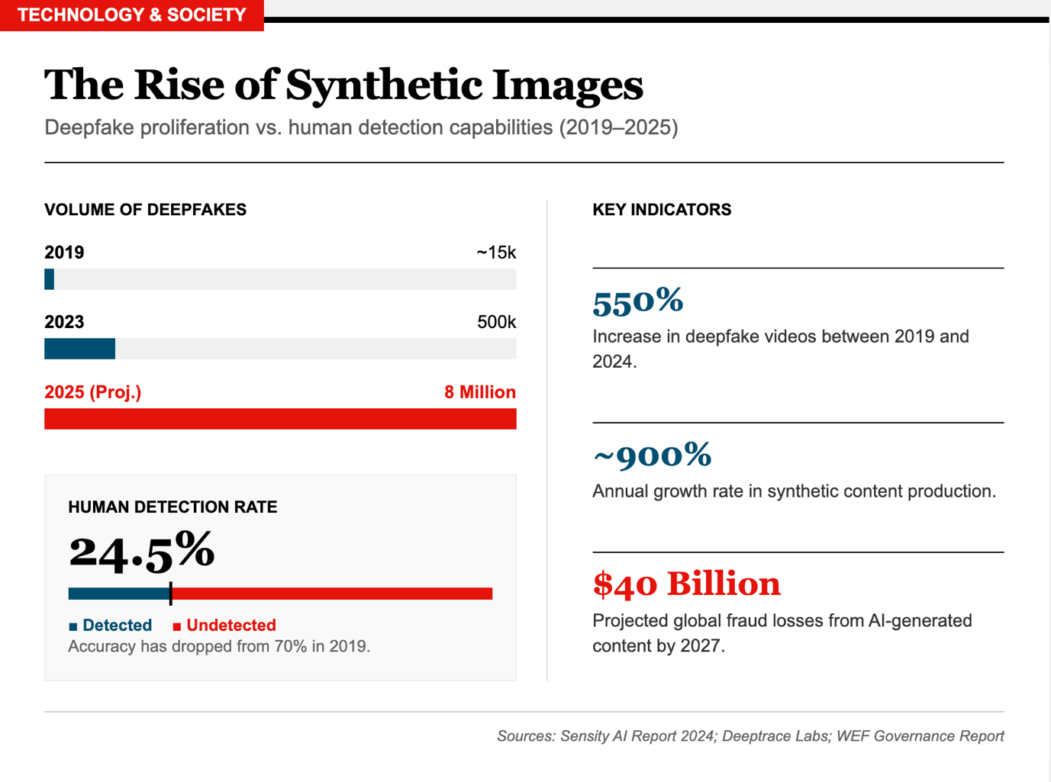
Task:
Give a five-minute talk on the rise of synthetic images in which you
- Explain the data and what it reveals about the growth of synthetic imagery.
- Comment on whether the decline in human detection ability should be considered a serious problem.
- Analyze possible responses to this challenge and discuss which stakeholders should take action.

PART 2 — Paired Activity
Task: You are student representatives working with a digital security expert to develop a 'Deepfake Awareness Program' for your school.
Together with the expert, discuss these program elements and agree on three to prioritize:
- Interactive workshop: 'Spot the Fake' — can students identify deepfakes?
- Guest speaker from a fact-checking organization
- Practical guide to reverse image search and verification tools
- Discussion of legal and ethical issues around deepfakes
- Creating a school policy on AI-generated content in assignments

